Alphabetical_Testing – Hard (Solved) Screenshots

Pragathi M Porawakara Arachchige

VBA Assignment – HW 2

for the Data Analytics Boot Camp

Washington University

April 2019

**Alphabetical_Testing – Hard (Solved) Screenshots**

Related Workbook Name – alphabetical_testing – Hard (Solved).xlsm

Tab – A

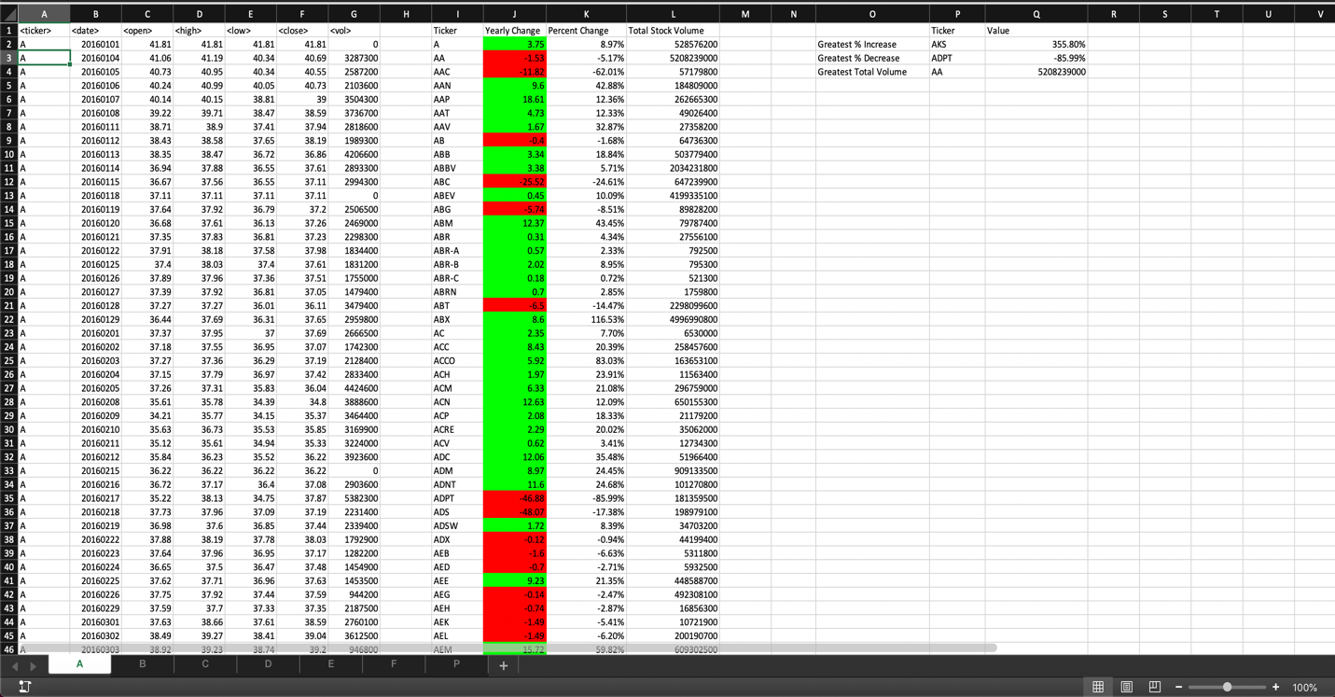

Tab - B

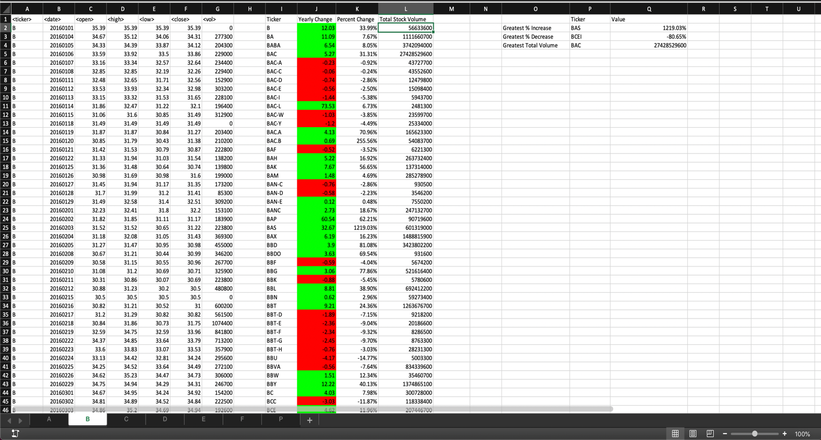

Tab - C

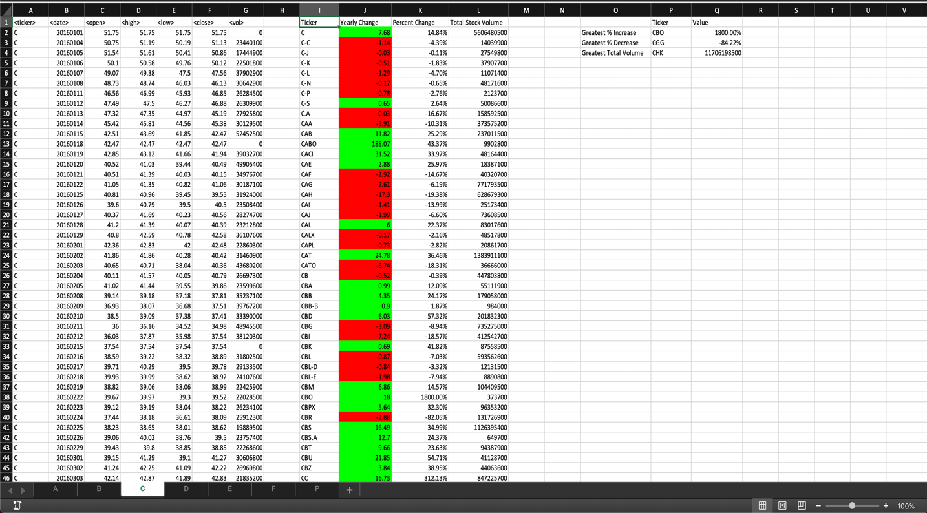

Tab - D

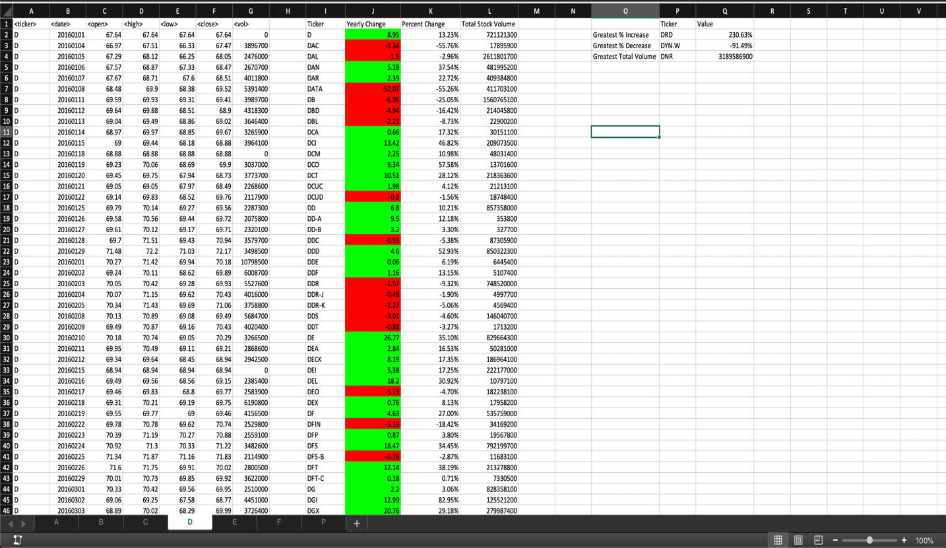

Tab - E

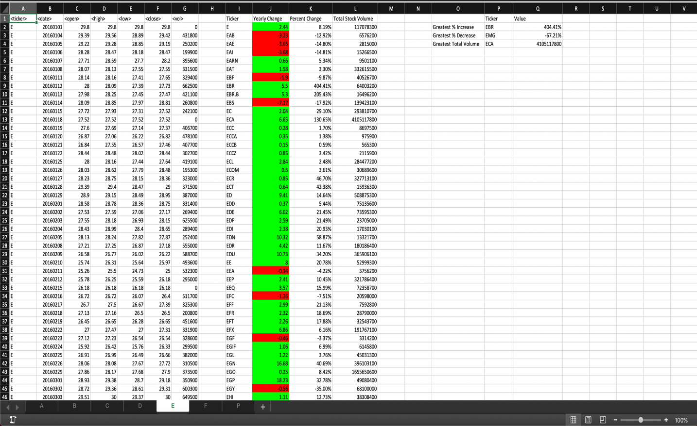

Tab - F

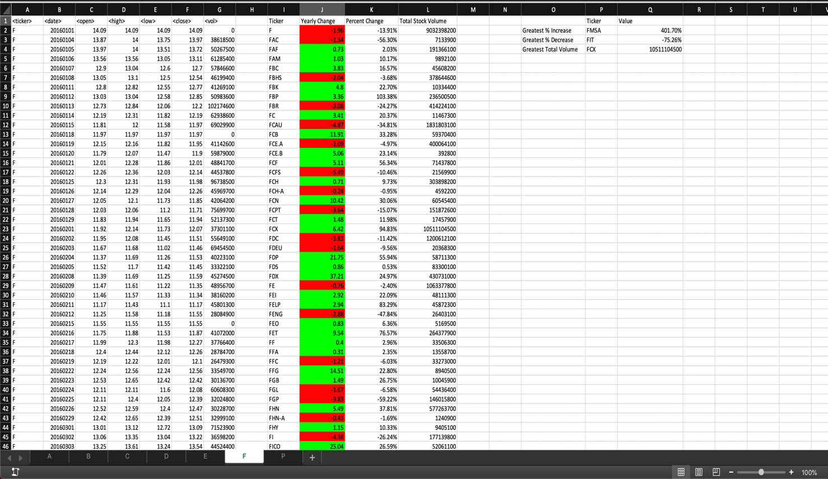

Tab - P

